Homework: Programming Languages
Problems for homework for the "Software Technologies" course @ Software University
Submit this document as your homework.

JavaScript
- Open the Browser Console.
- Create a JS function for calculating and returning the area of a rectangle.
- Create the constants needed and assign some random values:
- Execute the JS function in the Browser Console:
- Print the calculated area on the Browser Console in the following format: "The area of the rectangle is: areaValue sq.cm." :
- Example:
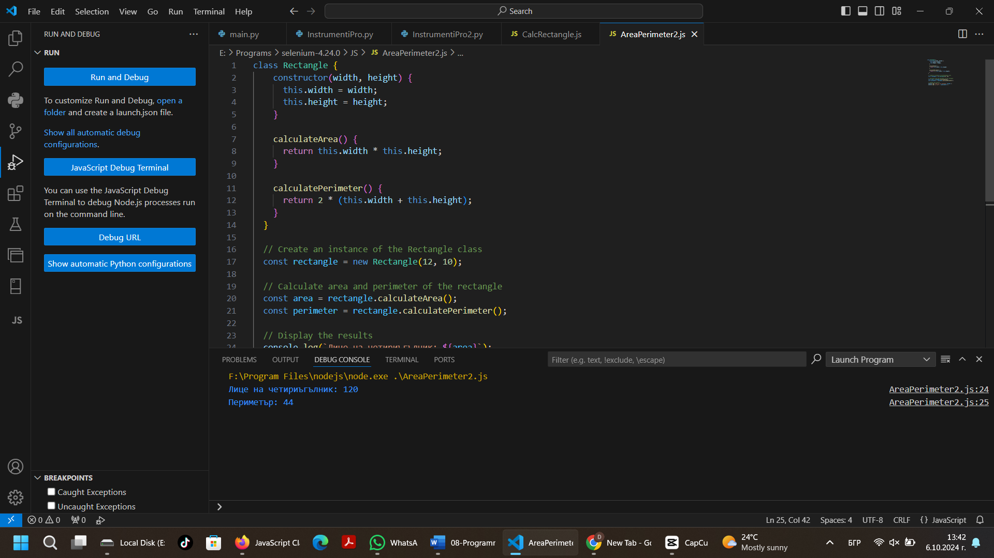
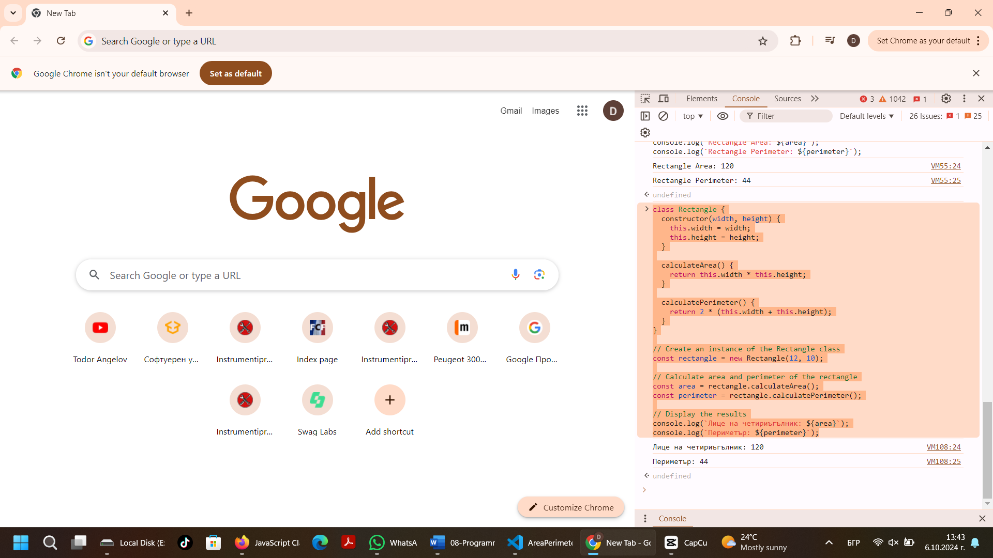
- Replace all example pictures with screenshots from your PC.

HTML & CSS
- Using the tutorial from the Exercise Document, Crate a simple Web Page that looks like the Example Below.
- Example:
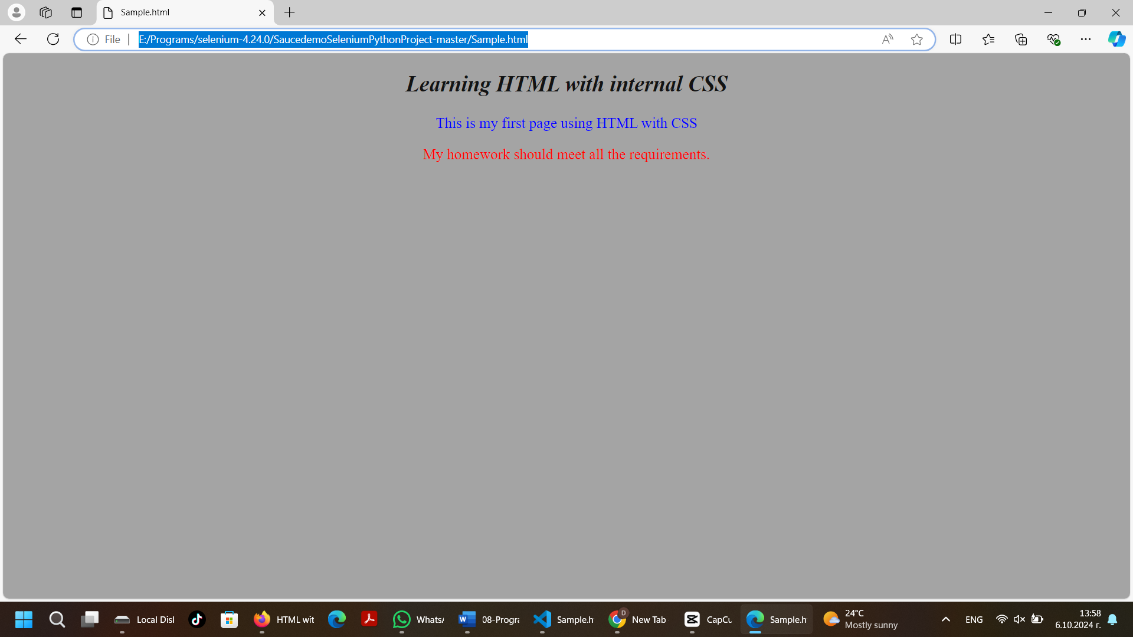

- Replace all pictures with screenshots from your PC.

